Having Fun at School 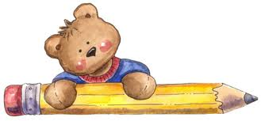
Feb. 7th to 11th : Monday to Thursday
Feb. 14th to 17th : Monday to Thursday


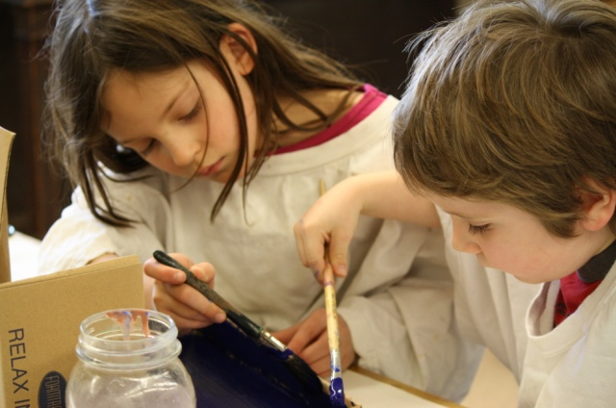
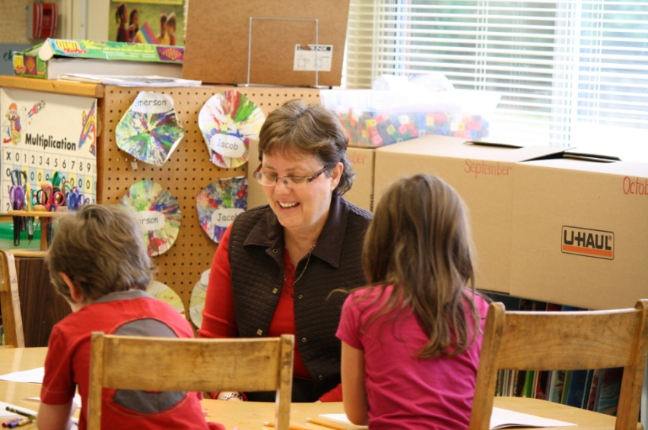
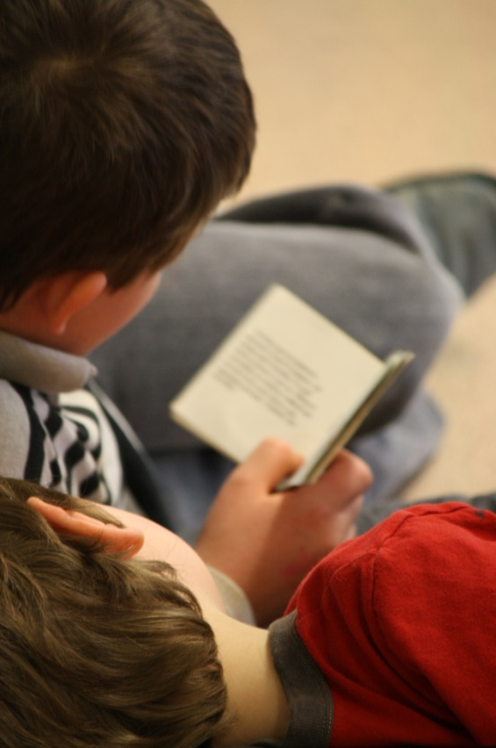
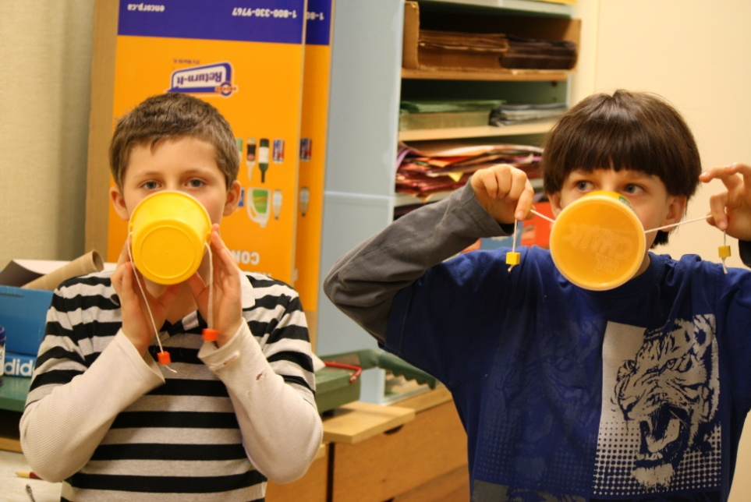
Spring is on its way!

After so much wet weather, we are glad to see clear skies. If it is not raining, the students will play outside until the bell rings at 8:30 am. The fresh air and activity are a great way to start the day.
Field Trip February 8th.

We will be going for our last session of bowling. This week we enjoyed our visit to the Royal British Columbia Museum. The Grade 4s have been studying about traditional Pacific West Coast aboriginal people. Seeing the artifacts made this come alive for us.
Kindergarten Registration
for 2011-2012

Students born in 2006 should register at the school next week. Please bring a Birth Certificate and Care Card.

